Week -

**Aim**: To Implement Mapreduce in java.

**Program**:

**Mapper.java**

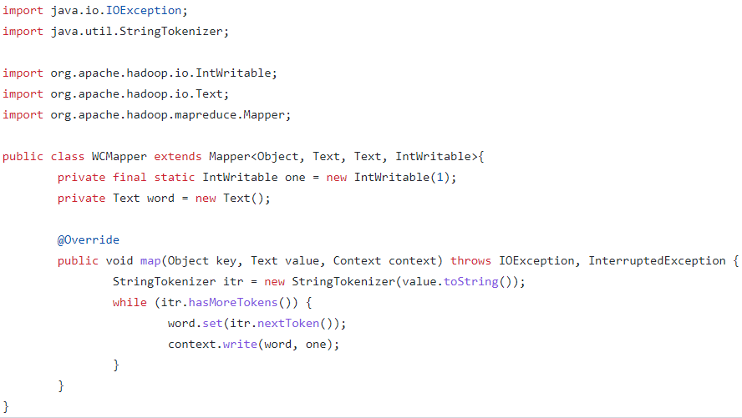

**Reducer.java**

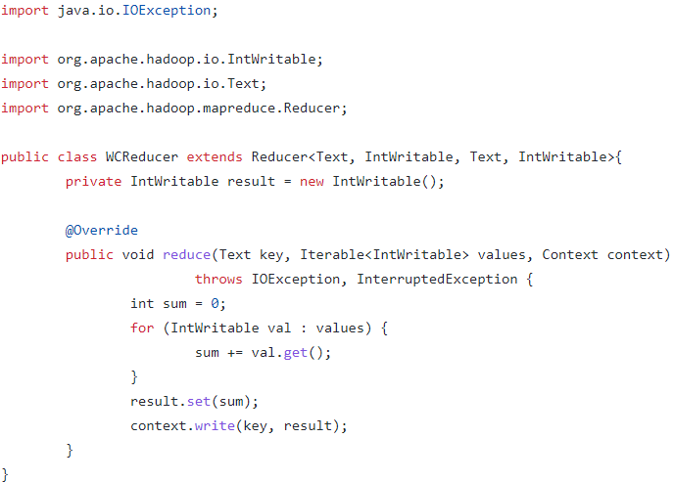

**Driver.java**

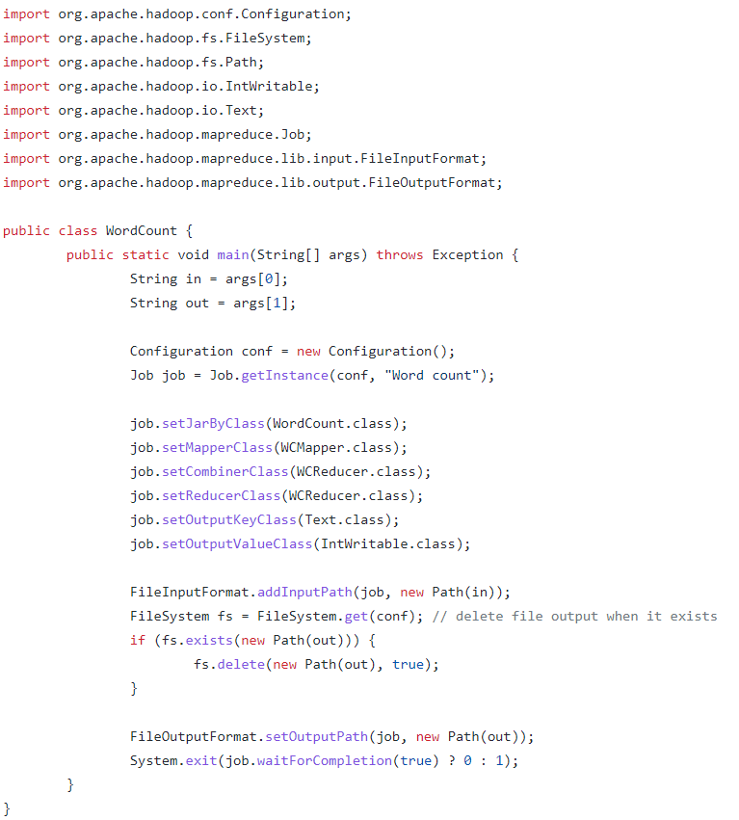

**Command:**

hadoop jar wordcount.jar Driver /user/cloudera/words.txt /user/cloudera/output/

**Output:**

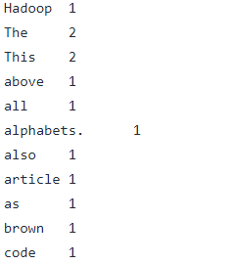

**Result:** Successfully Implemented Word Count using Mapreduce in java.

Week -

**Aim**: To Implement Mapreduce in Python.

**Program**:

**Mapper.py**

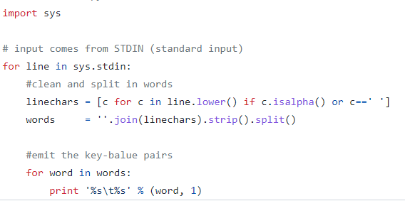

**Reducer.py**

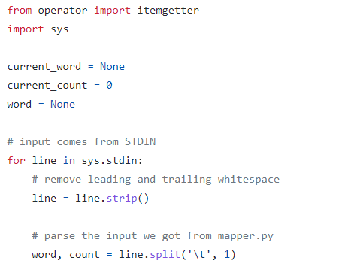

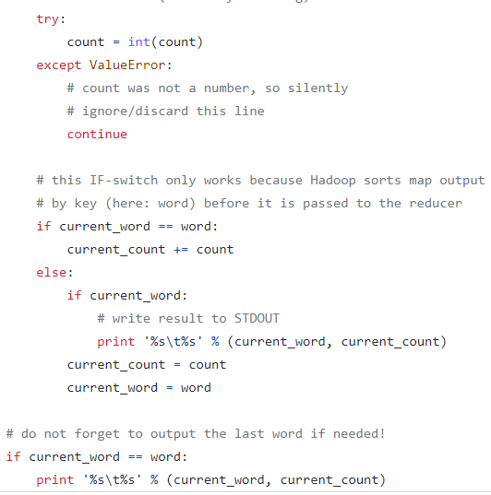

**Command:**

$HADOOP_HOME/bin/hadoop jar $HADOOP_HOME/share/hadoop/tools/lib/hadoop-streaming-2.3.0.jar \ -mapper ./mapper.py -reducer ./reducer.py -input wordcount-input -output wordcount-mapreduce-streaming-python-output

$HADOOP_HOME/bin/hadoop fs cat wordcount-mapreduce-streaming-python-output/*

**Output:**



**Result:** Successfully Implemented Word Count using Mapreduce in Python.